1. Develop a case study using UML for Passport Management System, It should verify the passport details of the applicant by the central computer. The details regarding the passport will be provided to the central computer and the computer will verify the details of the applicant and provide approval to the office. Then the passport will be issue from the office to the applicant.

***USE CASE DIAGRAM:***

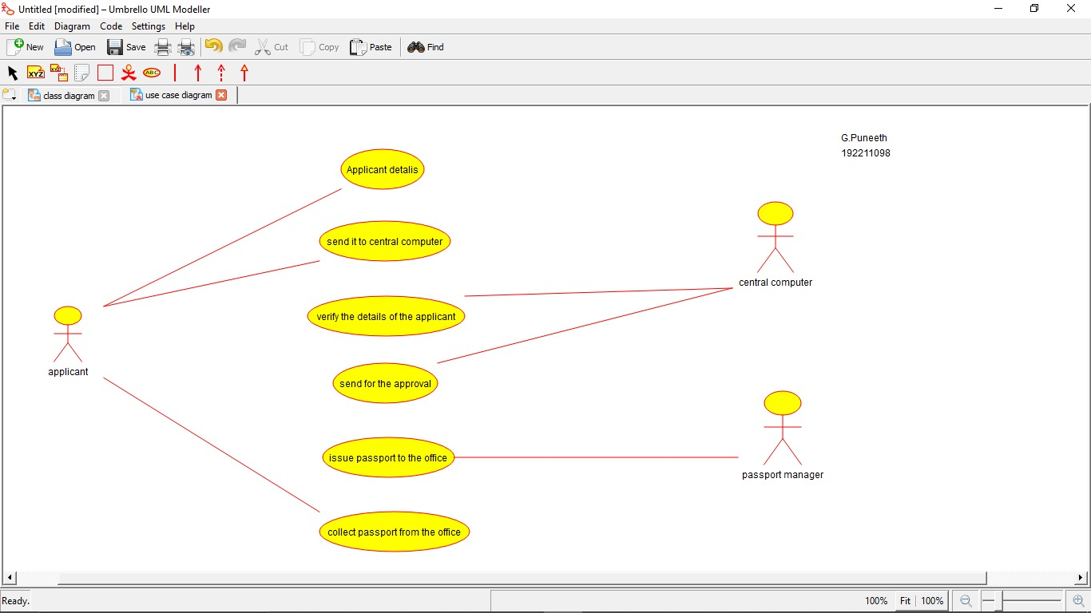



***ACTIVITY DIAGRAM:***

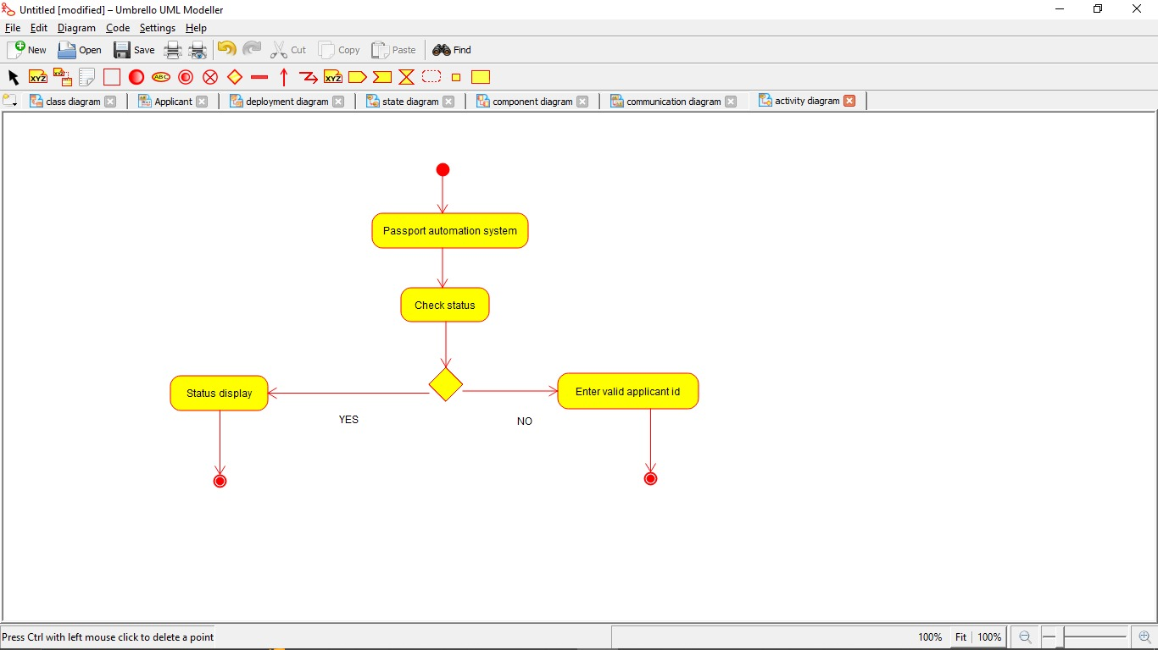

***CLASS DIAGRAM:***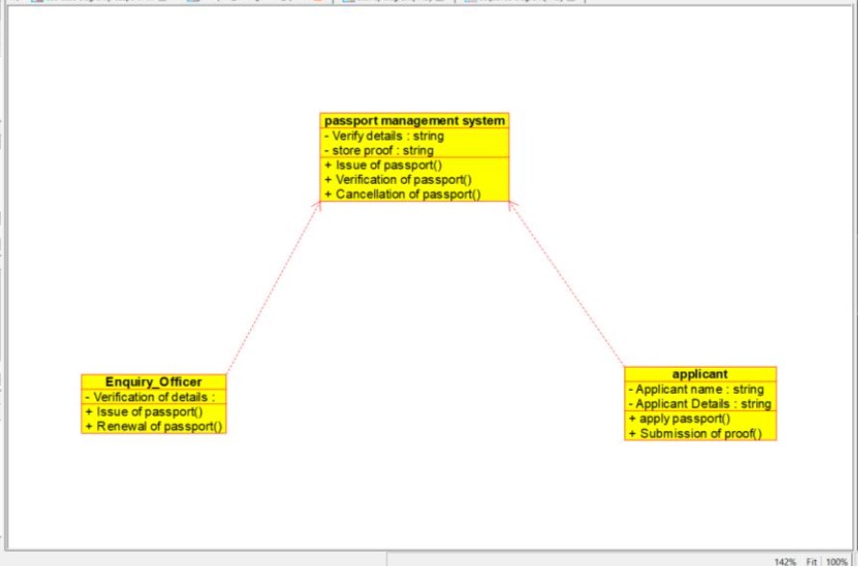

***STATE DIAGRAM:***

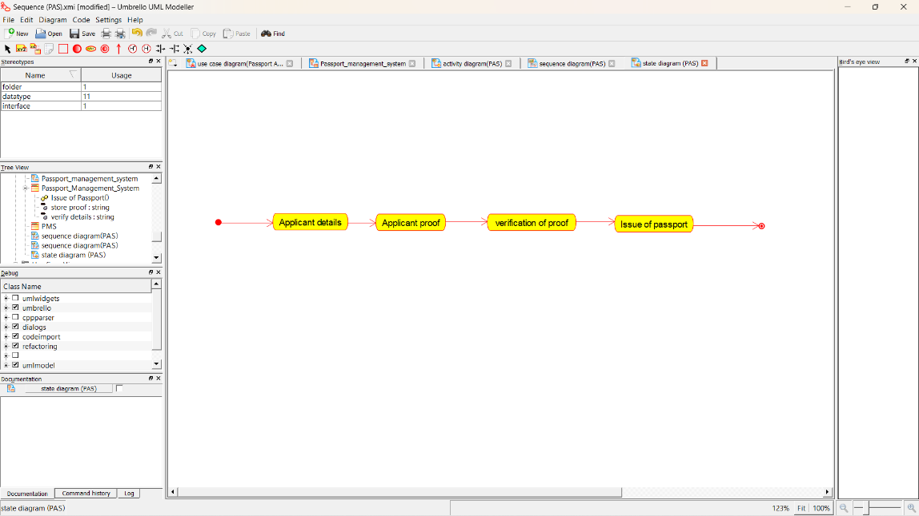

***SEQUENCE DIAGRAM:***

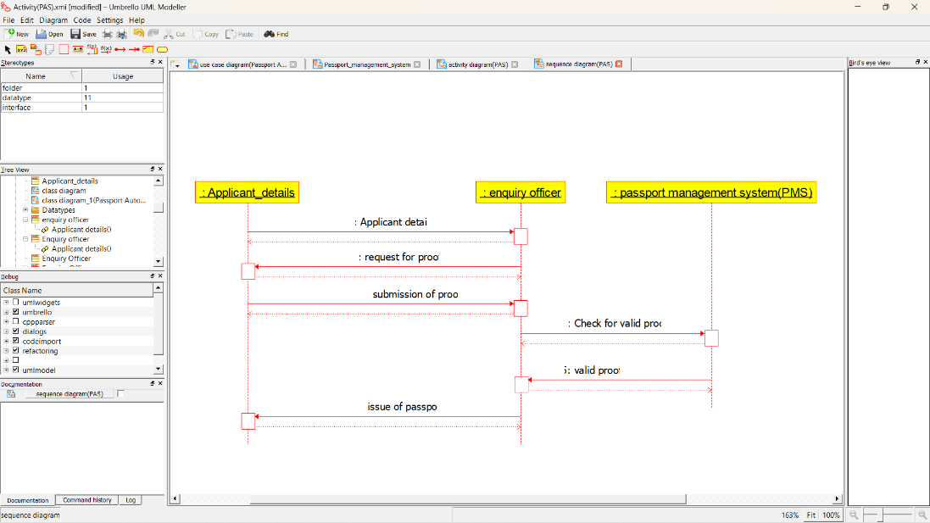

***COLLABORATION DIAGRAM:***

